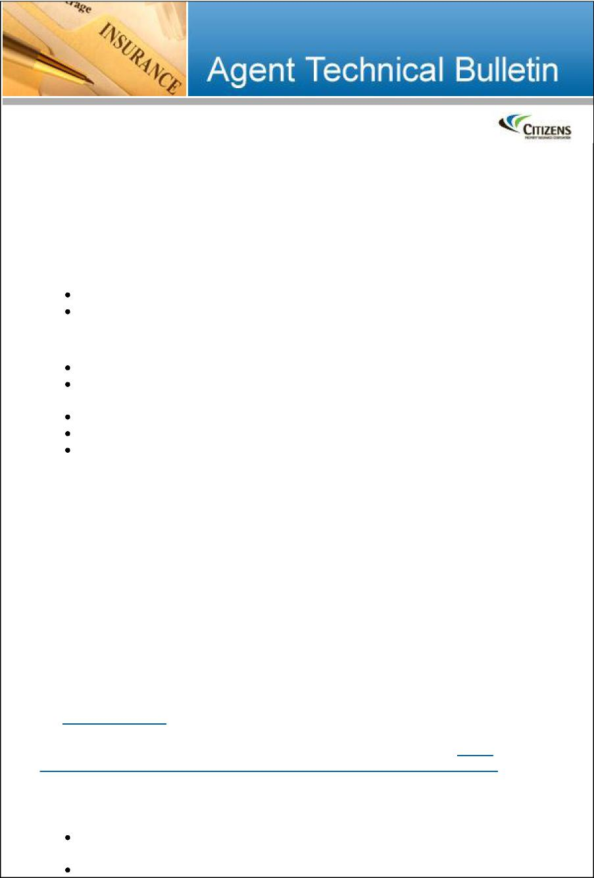

**Personal Residential**

**Rules, Forms and System Changes**

ATB #015-12 – August 02, 2012

Citizens is implementing the following underwriting changes for personal residential risks with effective dates on or after:

September 1, 2012 – new business October 1, 2012 – renewals

**Underwriting Changes**

Four-point inspections required for homes more than 30 years old (PR-M)

Applications for mobile homes more than 30 years old must be submitted

unbound

New plumbing rules (PR-M)

Revised electrical rules (PR-M)

Permitted Incidental Occupancies (PIO) coverage no longer is available

(PR-M and PR-W)

**Four-Point Inspections**

To ensure that the condition of the property is acceptable and all major systems (electrical, heating, plumbing and roofing) are in satisfactory condition, a four-point inspection must be submitted with all PR-M applications for homes more than 30 years old. We currently require these inspections on homes more than 50 years old. For new business with effective dates on or after September 1,2012, this requirement has been expanded to all homes more than 30 years old. The inspection must have been completed within the last 12 months prior to the submission date by a verifiable, certified inspector (Florida-licensed). *This rule does not apply to tenant named insured policies or condominium risks*.

If an inspection reveals unacceptable conditions, the property is not eligible for coverage. For a list of unacceptable conditions, refer to *Uninsurable Properties* in the [*Rules of Practice*](https://www.citizensfla.com/agent/um_personallines.cfm?manual=current&link=/shared/manuals/manuals-pla/current/1HO_ROP.pdf) manual.

*Note*: Eligibility rules for roofs more than 25 years old still apply. See [Agent Technical Bulletin #005-10: *Personal Residential Rules and ePAS Changes*](https://www.citizensfla.com/shared/ATB/ATB005-10/ATB005-10.pdf) for more information.

For mobile homes *(does not apply to tenant named insured policies*):

Applications for mobile homes more than 30 years old must be submitted

unbound and require an acceptable four-point inspection.

Applications for mobile homes more than 50 years old must be submitted

unbound and require documentation verifying that the electrical, heating,
  
plumbing and roofing systems have been updated within the last 35 years.

Existing policies will not require a four-point inspection to retain coverage unless required by an underwriter.

*Note:* Citizens has created an optional, [4-Point Inspection – Personal Lines](https://www.citizensfla.com/shared/forms/pla-submission/appsub/4-PointInspection-PersonalLines_Citizens-Insp4pt_09-12.pdf) form, which includes instructions outlining the level of detail required for a complete four-point inspection, conducted by certified inspectors (Florida-licensed). This specific form is not required, but we strongly encourage its use to ensure that all necessary information is provided. The form lists the minimum information needed to verify the types, ages and conditions of a home’s four major systems for determining eligibility with Citizens. A photo requirement is outlined at the top of the form. Also required are specific details and descriptions of all updates, hazards noted, etc. If this form is not used, an inspection company’s form is acceptable as long as it contains the same information**.**

**New Plumbing Rules**

Properties with the following plumbing-related conditions no longer are eligible for coverage with Citizens:

Signs of active leaks or unrepaired water damage identified during a visual



inspection

Plumbing systems not in good working order

Properties with polybutylene plumbing

**New Electrical Rules**

|  |  |
| --- | --- |
|  | Requirements for remediation of aluminum branch circuit wiring have been added.  New risks with electrical service of fewer than 100 amps are not eligible for coverage.  *Mobile home exception:* If electrical service is fewer than 100 amps, an exception may be granted if documentation is submitted showing that the amp capacity is sufficient for the property. The documentation must have been completed by a Florida-licensed electrician, journeyman electrician or building code inspector within the last five years. |

**Permitted Incidental Occupancies Coverage Removed**

Permitted Incidental Occupancies (PIO) coverage no longer is available on any Citizens policy. This change affects policies with this optional coverage for property and liability associated with a home business. Properties with incidental business exposures still may have a minimal amount of *Coverage C – Personal Property* coverage automatically provided in the base-policy contract. There is no business-related liability coverage in any Citizens policy.

The PIO coverage endorsement will be removed from policies renewing October 1, 2012, and later.

Agents with policyholders impacted by the elimination of PIO coverage will receive an email with additional information and a list of affected policies.

**ePAS System Enhancements**

The following ePAS enhancements have been made to support the above changes:

A *Four-Point Inspection Date* field has replaced the *Updated Wiring* and *Updated Heating* fields on the *Rating* tab for non-mobile home policies. A *Four-Point Inspection* Date field and *Updated Plumbing* field will display for mobile home policies.

A new polybutylene-piping question will display on the *General* tab.

Question 6 on the *General* tab has been revised to reflect the electrical rule change.

*Permitted Incidental Occupancy* and all related fields no longer will display on the *Coverages* tab.

An automated journal entry will be added when a system change noted above affects a renewal policy dated on or after October 1,2012 or later.

Any coverage change will be outlined in the *Notice of Change in Policy Terms,* which will be included with the renewal package. The content of each notice will vary by policy form. Samples of notices can be found in the 2012 section of the [*Annual Changes: Rates, Rules and Forms*](https://www.citizensfla.com/agent/trm_annualchanges.cfm) tab under [*Training and Reference Materials*](https://www.citizensfla.com/agent/trm_whatsnew.cfm) on the [*Agents*](https://www.citizensfla.com/agent/index.cfm) section of our website.

Agents and CSRs may submit underwriting questions via the [Contact Us](https://www.citizensfla.com/utilitybar/contact.cfm) option on our [website.](https://www.citizensfla.com/index.cfm) You should receive a response within three business days.



This email is not spam. Citizens Property Insurance Corporation communicates by email. You received this email because you are an appointed agent with Citizens or we received a request to add your address to our email distribution list. If you are an appointed agent, removing your name from the distribution list requires termination of your appointment. To have your appointment terminated, contact Agent Administration at [agents@citizensfla.com](mailto:agents@citizensfla.com) or 800.737.5822. If you are not an appointed agent or if you received this message in error, you can [unsubscribe](https://www.citizensfla.com/agent/ac_subscribe.cfm?email=unsubscribe) via our website.

**Citizens Property Insurance Corporation**[**www.citizensfla.com**](http://www.citizensfla.com/)